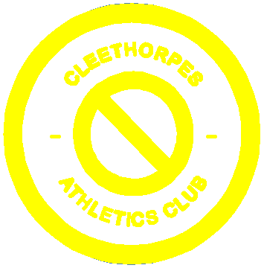

CLEETHORPES ATHLETICS CLUB
ATHLETICS 365

Athletics 365 is a multi-event, young people development programme, which introduces athletes to the fundamental skills of athletics. The programme focuses not only on how fast someone runs or how far someone jumps or throws, but also more importantly, on developing the technical skills required to perform at full potential. In addition to technical skills, Athletics 365 also looks at an athlete's physical, mental and emotional development, as well as their lifestyle and social development.

The Athletics 365 programme is broken down into nine progressive stages. Each stage provides athletes with new and progressively more difficult challenges appropriate to their stage of development. Through the programme, athletes are encouraged to learn all skills and events of athletics, and this reinforces the importance of a good, all round skill base.

Currently, the club is in the early stages of developing the Athletics 365 programme and has begun trialling this with a small group of athletes. The club has participated in an Athletics 365 coaching workshop which involved coaches, parents and athletes. It has also sent a number of people on the Leading Athletics Course with the view that these people will support the development and growth of the 365 programme.

